CREATING A HASHTAG GENERATOR ON FACEBOOK AND INSTAGRAM.

**Team Name:** SPARK LIGHTS

**Team leader NM Id: Velmurugan.R au420720105059**

**Dhaneshvaran.E au420720105013**

**Surya.S au420720105055**

**Pandidurai.E au420720105305**

**Brand Name:** NWM Buisness

**Category: Nike Mens Wear**

**Target Audience: Mens**

**Email:** nikemenswear@gmail.com

**Facebook Business Page:** [https://www.facebook.com/profile.php?id=61552](https://www.facebook.com/profile.php?id=61552722113642)566301976

**Instagram Business Page:**[https://www.instagram.com/nwmbuisness?igshid=MzNLNGNKZWQ4Mg](https://www.instagram.com/nwmbuisness?igshid=MzNLNGNKZWQ4Mg==/)= =

Documentation:

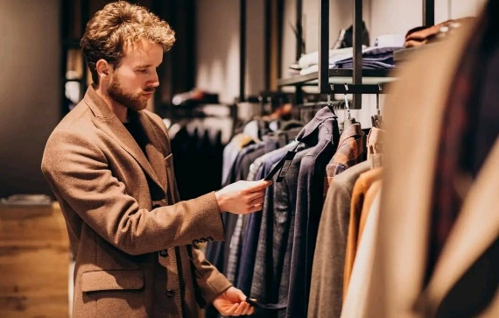

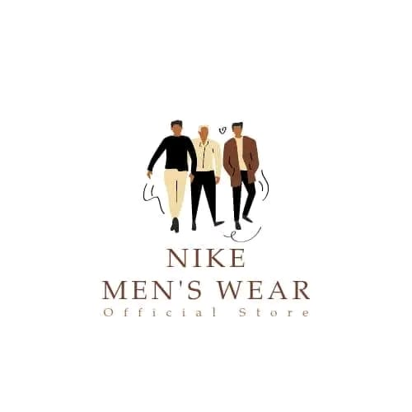

Brand logo Cover Photo

Social Media Preview

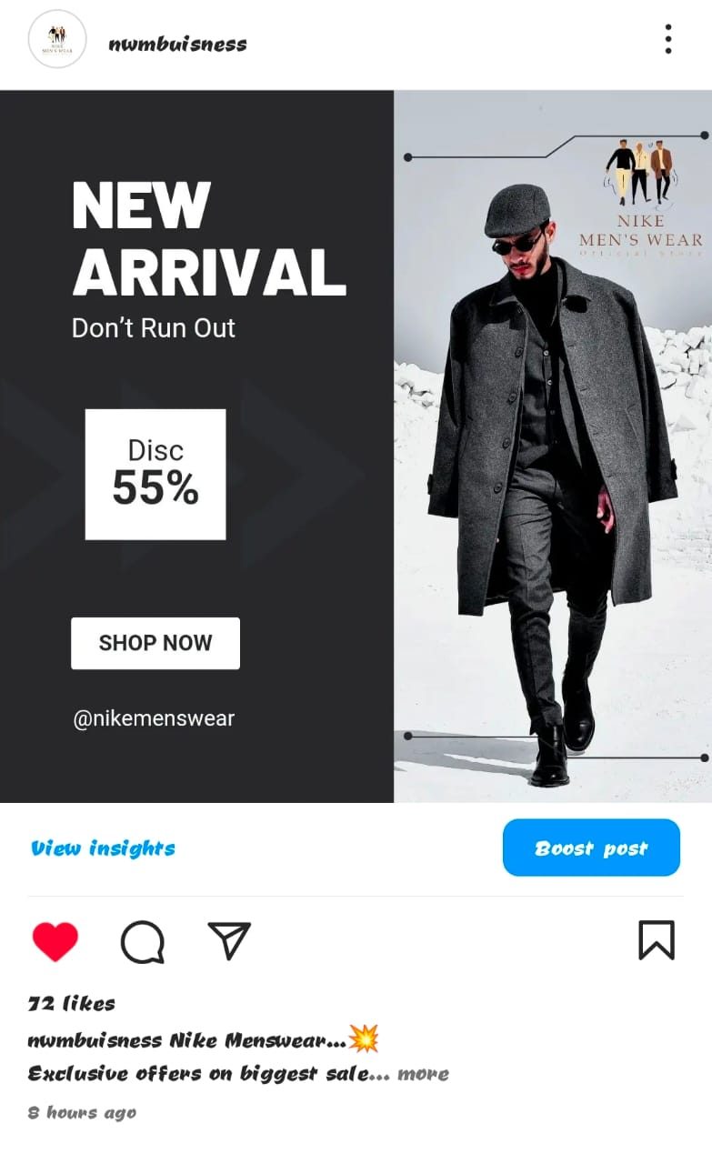

PROFILE PREVIEW: Instagram

oi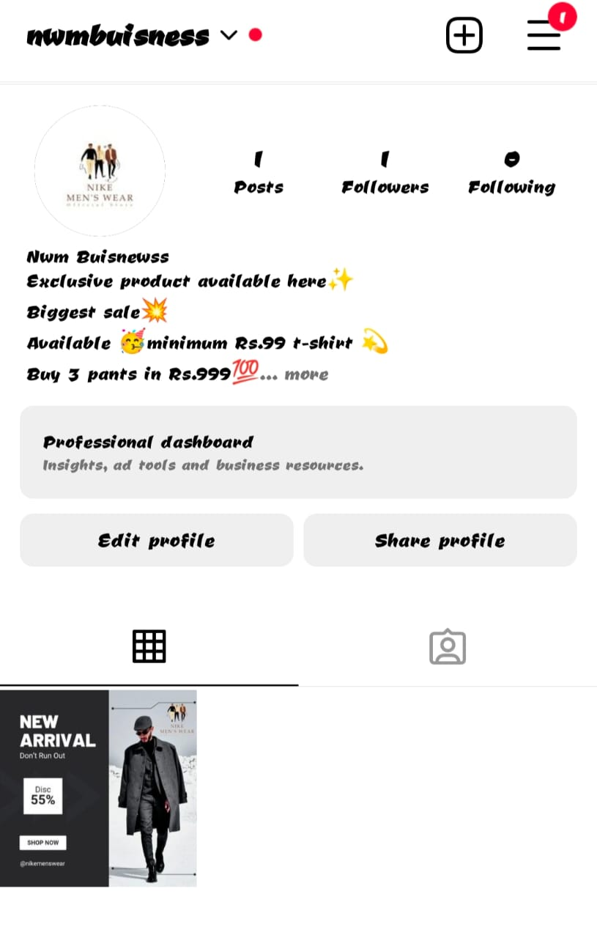

facebook profile :

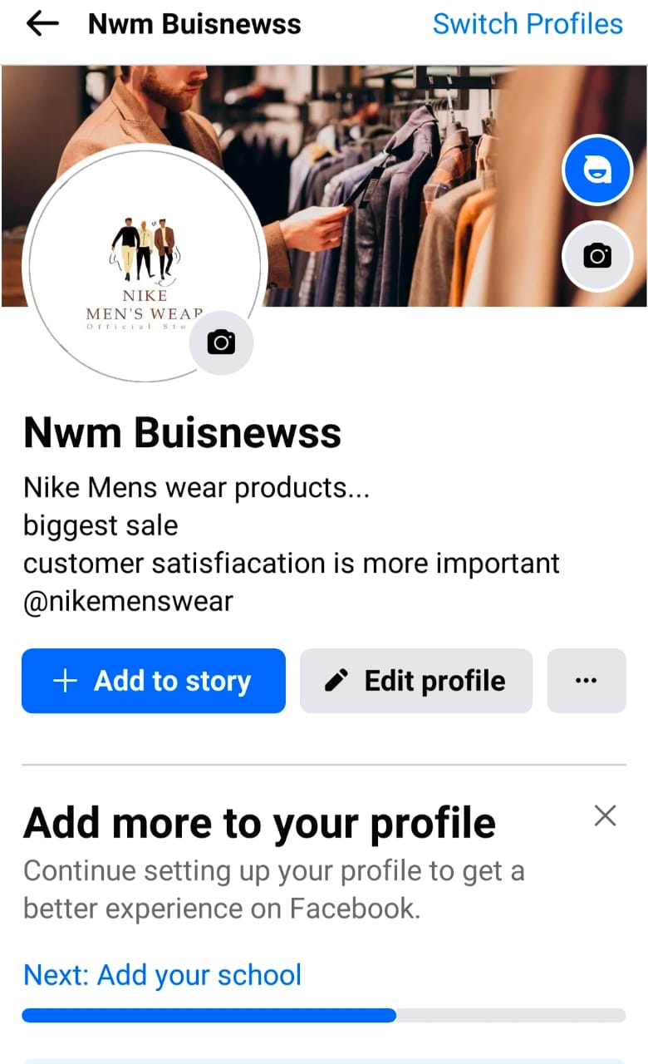

Social Media poster :

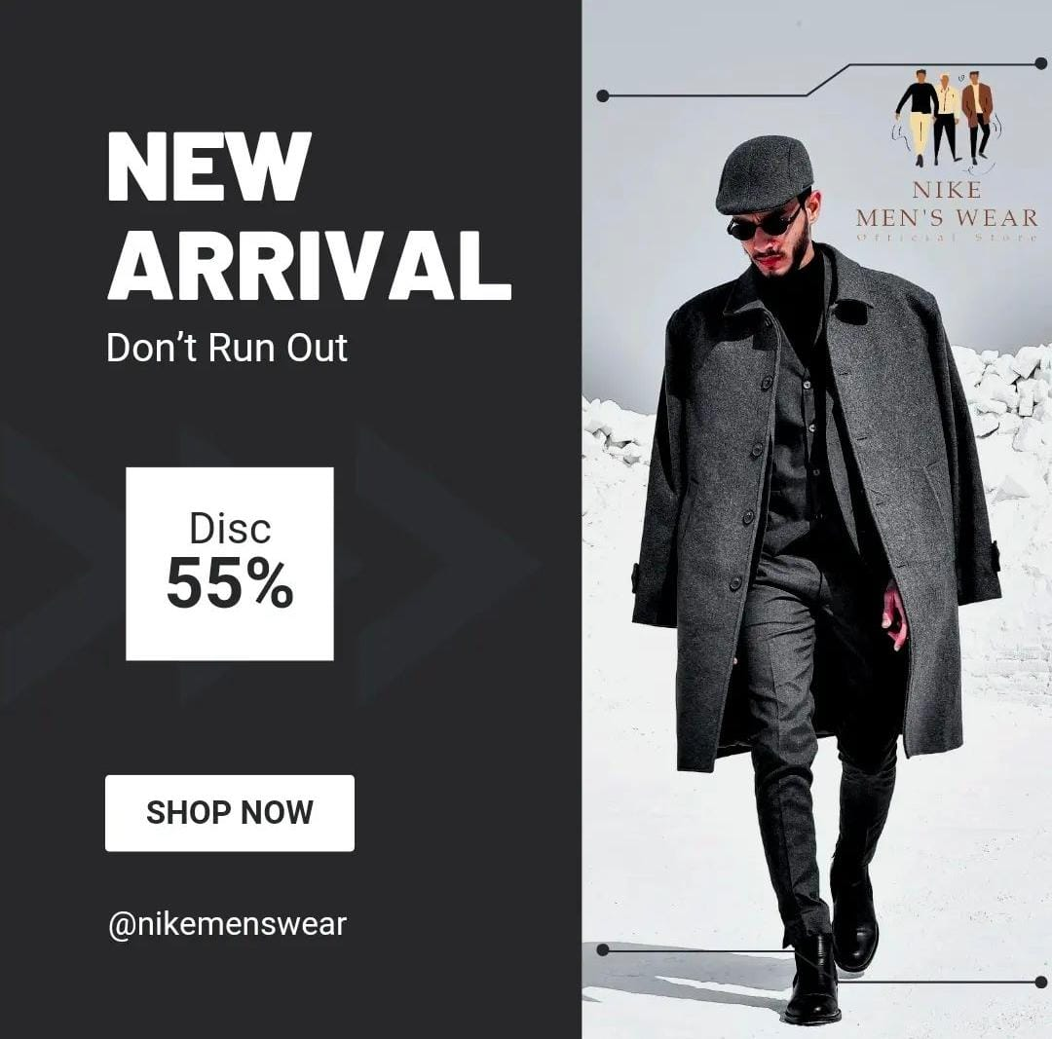

Vedio link :<https://github.com/velmurugan333/Nike-Mens-Wear.git>